

# Hellscent

Author: Alex Knotwell

# Elevator pitch

We're developing a top-down RPG game set in a medieval fantasy world inspired by European folklore. Its gameplay is primarily action based where players will fight against different types of enemies as they descend farther into hell.

# Concept

## Overview

* **Genre:** Top-Down RPG / Action
* **Target audience:**
  + **Age:** 12+
  + **Gender:** Male/Female
* **Monetization:** None
* **Platforms & system requirements:**
  + Browser

## Theme and setting

Hellscent is a role-playing game set in a historical fantasy version of  biblical hell. The player takes on the role of the Stoic Knight and gets to explore nine randomly generated levels. As he treads deeper into the depths of hell he must vanquish the archdemons in order to stop them from entering the mortal plain.

## Timeline

* September: Initial brainstorm and onboarding.
* October: Start designing features individually. We started working on procedural generation, unique weapons and enemies and a basic UI.
* November: We finished procedural generation and started to put things together. Added enemy spawners into the generated map. Added animations for an enemy and running animation for the player.
* December: ?
* January:

# User Experience

## Intended Player Experience

Player should have a new experience whenever the game restarts. It should take multiple tries to beat the game, with the difficulty increasing per level.

## User Interface

### Health

Health bar that changes based on damage to the player.



### Mana

Mana bar that decreases when an attack is used. Automatically refills when player stops attacking.

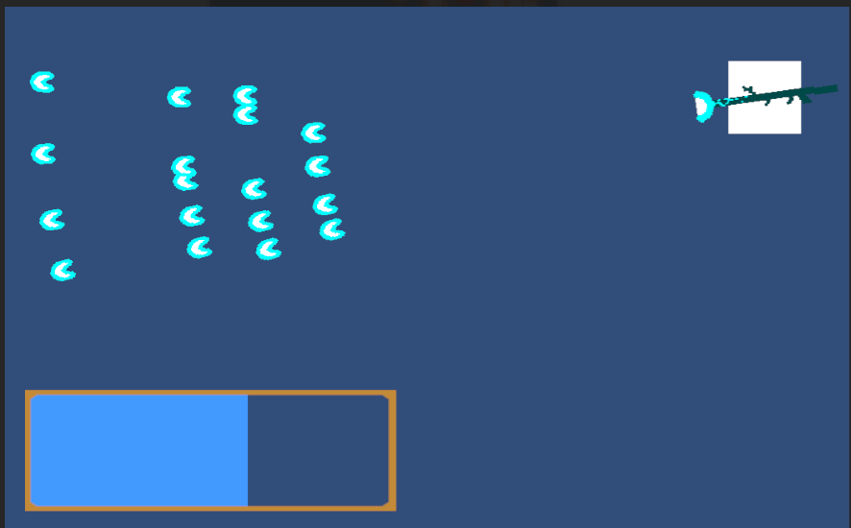

### Start Menu

Start menu that is the first scene shown when the game is started. When the "Start" button is clicked, switches scene to the one with procedural generation.



### Options

Added a simple options menu that can be accessed from the start screen. Can be used to change the volume and key binds.

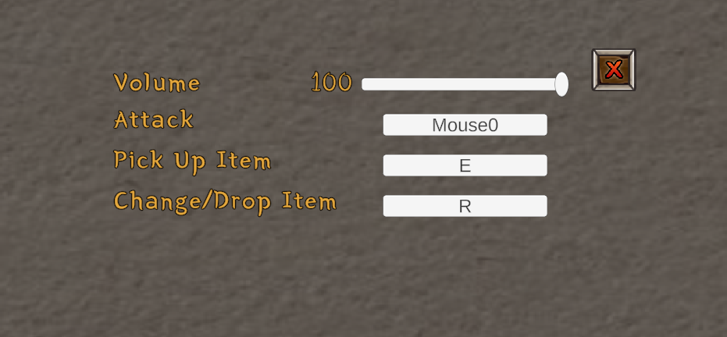

### Story Journal

When the 'j' key is pressed a journal will be displayed with torn pages that as you progress through the game you will collect story elements that will be added to the journal.



## Movement

* Smooth responsive movement, combined with a dash to make dodging and weaving fun and responsive

## Combat/Enemies

* Bullet-heck style swarms of projectiles together with varied enemy types, such as charging enemies, high agility chasers that detonate the moment the player gets close, hectic boss fights with complex bullet patterns, and enemies that can use the exact same weapons that the player uses

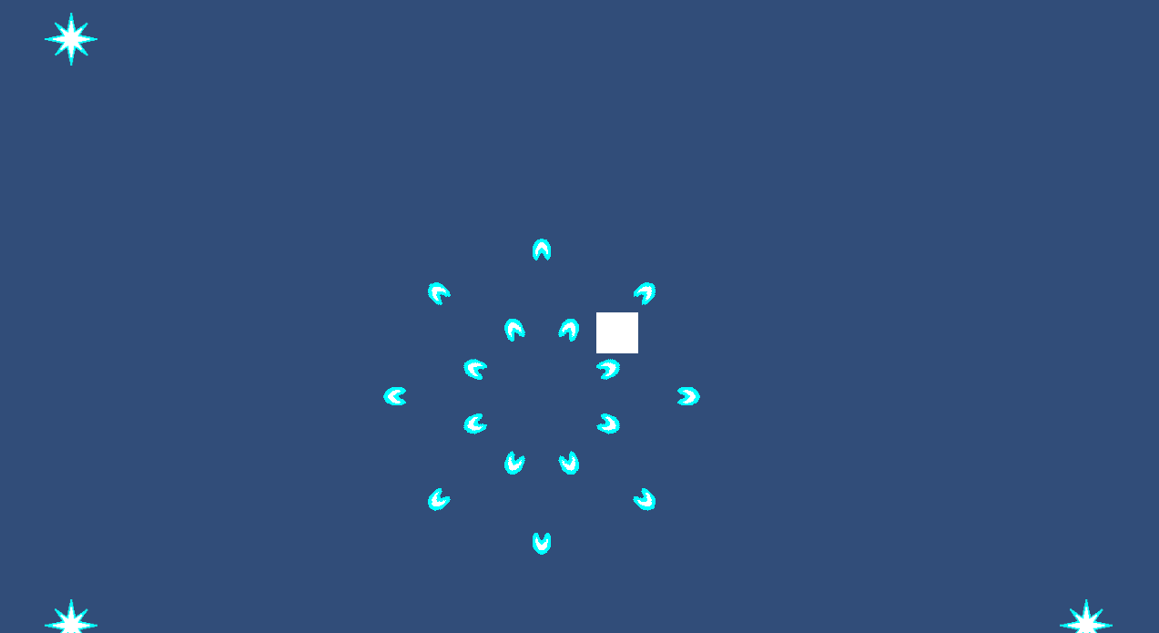

## Animations

Angry Slime:

[Media1.mp4](https://files.nuclino.com/files/f1fe40c5-ec80-45d8-954f-57bca9fc9f08/Media1.mp4)

Player walk:

[playerwalk.mp4](https://files.nuclino.com/files/3158e5b0-1e4c-4b8a-8010-937d82f9ebb7/playerwalk.mp4)

## Weapons

* Featuring multiple base weapon types, such as the shockgun, a lightning slinging weapon with many projectiles yet horrid accuracy, the sun launcher, a jury-rigged wand retooled for launching huge high damage projectiles to tear through enemies, if they walk in to the slow moving orb of destruction, and, yet to be implemented, a cannon that rewards players who can make judgements of time and distance on the fly with absurd damage upon getting the timing right, and the hailstorm, a weapon that chews through the player's resources in exchange for a torrent of projectiles, rending whatever poor fiend lays in its path.

# Build and Deployment

## Unity Engine 2022.3.9f1

## Beta Testing

Haven't chosen between WebGL or Unity File.

# Project scope

## Our team

* [Alex Knotwell](https://github.com/aknotwell) - Sprite Animation (lead)
* [Alex Minascurta](https://github.com/Alexander-Minascurta) - Story (lead), Room Generation, UI
* [Ben Wu](https://github.com/roar-k) - UI (lead),
* [Domingo Morales](https://github.com/Cologne32) - UI, GUI, Player Features
* [Gabriel Wong](https://github.com/gbrielw) - UI
* [Jack Nieman](https://github.com/LemoCoffee) - Weapons (lead), Room Generation, Enemies
* [Nikolai Repin](https://github.com/Nikolai-Repin) - Room Generation (lead)